



Precision Discharge Platform

May 2016

**Issue Analysis**

Readmissions after hospital discharge result in substantial burdens on the healthcare system, in terms of both cost and quality of care. The US Department of Health and Human Services estimates that readmissions contribute more than $15 billion a year in cost for Medicare patients alone, a significant portion of which is preventable.[1] Research by the Health Resource and Education Trust (HERT), an affiliate of the American Medical Associate, shows that identifying high-risk patients and effectively coordinating care are primary drivers for reducing readmissions.[2] Identifying high-risk patients to deploy targeted interventions is essential to triage limited hospital resources, especially for resource-intensive discharge plans that have been proven to reduce readmissions.[3] However, many hospitals lack the tools to accurately assess patient risk and effectively manage multi-step discharge plans. Moreover, due to newly established penalties under the Affordable Care Act, hospitals that care for vulnerable patient communities incur harsh penalties for high readmission rates. The shift to population health management, such as shared risk and capacitated reimbursements, exacerbates the need to reduce readmissions. Safety net hospitals are not only disproportionately affected by changes in federal penalties and reimbursements, but also suffer from limited resources – leading to lagging health information technologies and ultimately, a worsening disparity of care between the wealthy and poor.

One of the major challenges in assessing readmission risk is due to the complexity of analyzing vast and heterogeneous sets of patient medical records and claims data. The complex and disparate nature of patient records presents an ideal problem set for data science. Statistical risk prediction and machine learning could enable automated, real-time stratification of patient readmission and provide a basis for targeted delivery of intervention and transitional care. A web-based application that recommends, coordinates, and implements tailored discharge plans based on patient risk could enable hospitals to better allocation scarce hospital resources to help the highest-risk and most costly patients.

However, few data science approaches have been implemented in clinical practice, and even fewer are accurate enough for real-time clinical usage, particularly those that are robust across diverse patient populations. One major limitation has been the lack of data standards and technical infrastructure across hospitals to access, share, and integrate patient data. The lack of interoperability has lead to limited access to critical data sets and time-consuming and length data integration cycles. The adoption of FHIR across EHR vendors presents a critical opportunity to implement data science approaches rapidly across a spectrum of providers and patient populations.

**Solution**

Overview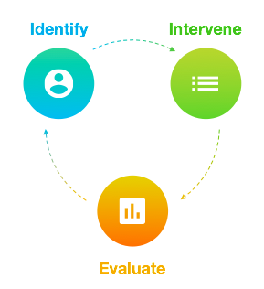

With funding through the Robert Wood Johnson Foundation, Bayes Impact is developing a precision discharge platform with a focus on safety net hospitals. Our tool will identify patients at high risk of readmission, deliver patient specific intervention, and evaluate care effectiveness (Figure 1). We are developing our product through two stages: first, building a predictive machine learning model that can stratify patients by their readmission risk and second, to co-develop the precision discharge platform with our hospital partners. 

Identify: The Bayes Impact Predictive Readmission Model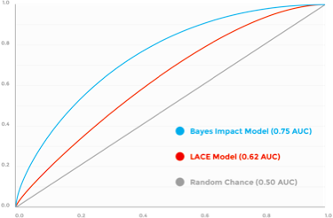

Bayes Impact collaborated with Sutter Health’s Research Development and Dissemination (RDD) team to develop a real time predictive risk score to identify high-risk patients. Our model utilizes patient data of over two million patients within the Sutter Health network to build a highly predictive risk assessment model. At the heart of the predictive engine is an adaptive machine-learning algorithm that evaluates patient’s risk profile based on previous electronic records system. Unlike LACE (the current industry standard), the machine-learning algorithm allows for multi-faceted and comprehensive risk profiling. Furthermore, this method is adaptive to patient population in different hospitals, and allows for a more accurate risk profiling among different cohorts. We have successfully tested the retrospective accuracy of our model, demonstrated via the graph in Exhibit 2.

Intervene: The Precision Discharge Platform

The discharge planning process is a critical driver of reducing readmissions. Over the course of our research and interviews with clinicians, hospital administrators, case managers, and patient advocates, we found that managing the discharge process once high risk patients are identified is highly varied both within and between hospitals. Furthermore, compliance with the instituted discharge or care plan is difficult to manage and assign. To achieve meaningful change to the quality of care, our product (Figure 3) addresses both the proper identification and management of high-risk patients. Our tool is launched from a link within the EHR page of each patient. Clinicians are then taken to the web-based application. 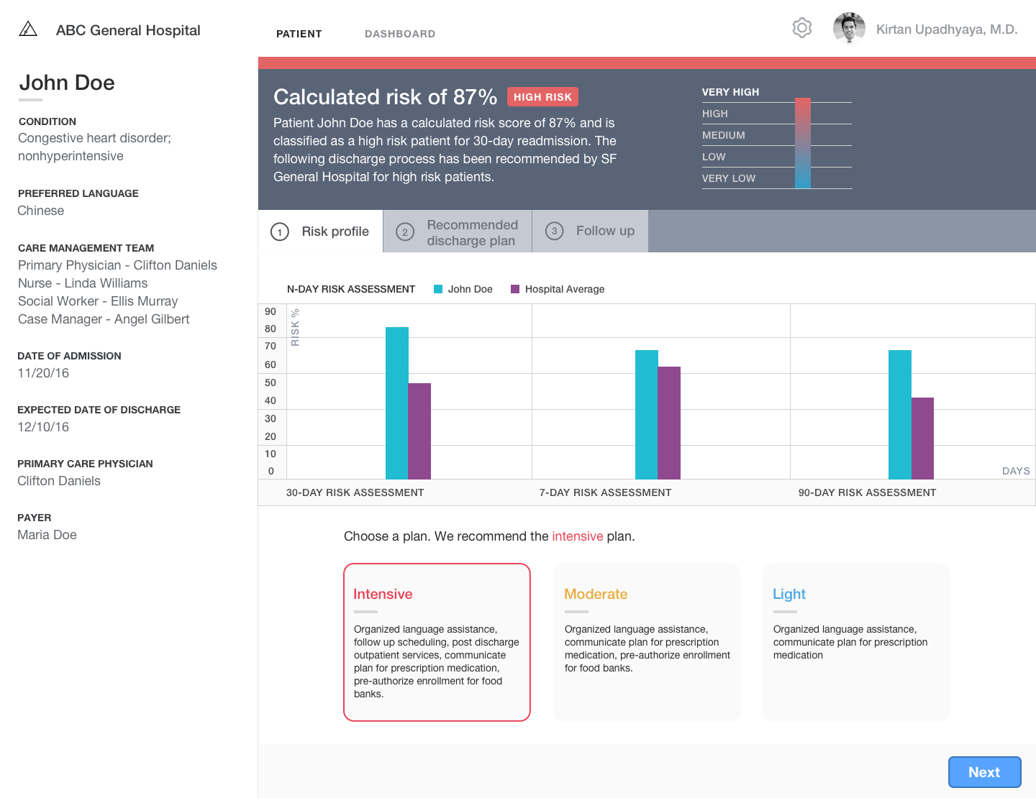

There are three main users for the web based application, with each user drawing different value propositions for using our tool: clinicians who can evaluate risk and chose an appropriate plan for the care team to follow, care teams who can check off items as they complete them and schedule reminders to patient on follow up care items, and hospital management who can track compliance and visualize hospital performance.

Evaluate: The Precision Discharge Platform

With text based questions such as “Did you attend your appointment on Thursday May 26th with your pulmonary specialist? (Yes/No)” or “Have you taken your evening medication? (Yes/No)” care teams can track patient compliance and intervene when necessary with phone calls or in-home care visits (Figure 4). Dashboards (Figure 5) can provide clinicians, care teams, and hospital administrators a snapshot of all patients currently in the ward. With simple indicators for high-risk patients and outstanding discharge tasks, hospital staff can efficiently manage multiple patients at a glance. Hospital administrators will also be able to assess hospital performance in real time via a hospital overview dashboard.

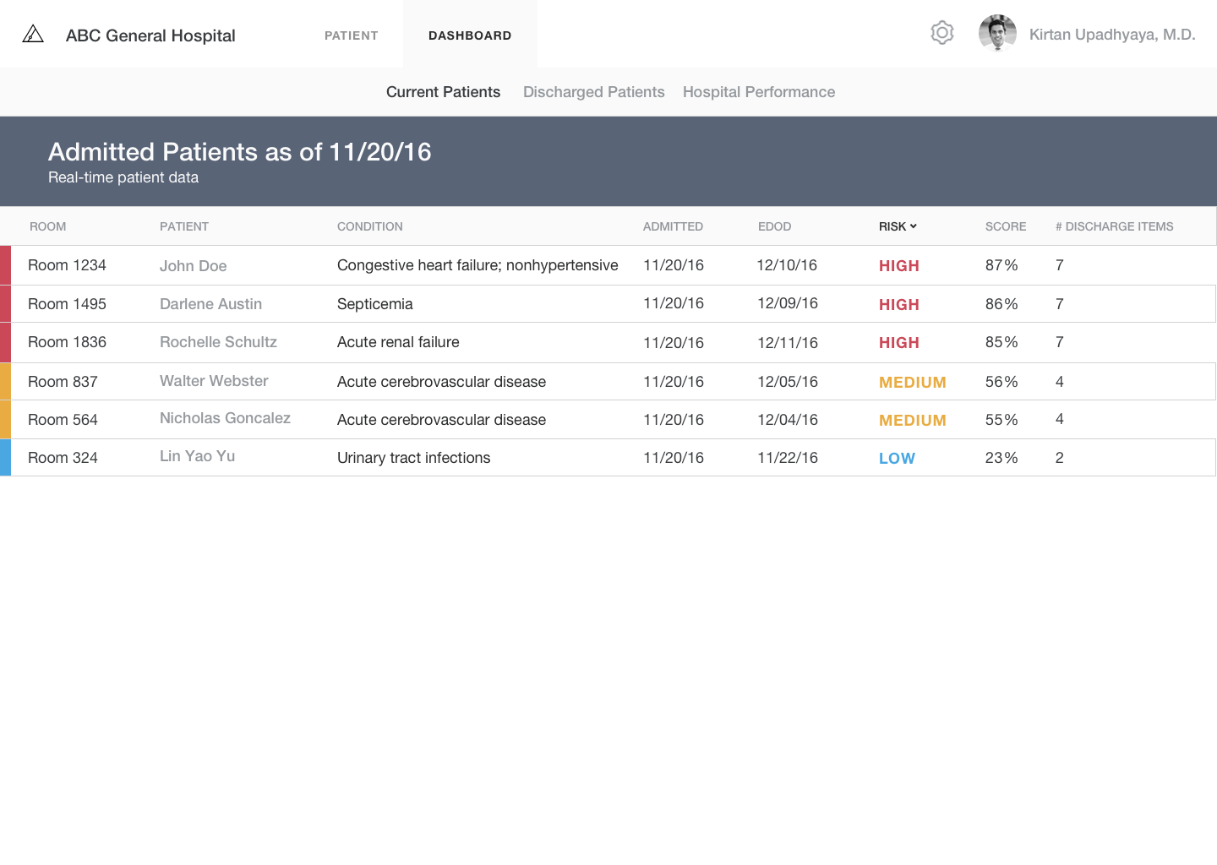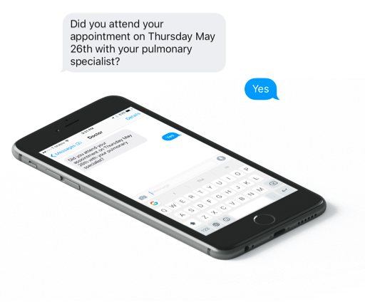

**Figure 5: All current patients dashboard highlight risk, important dates, and number of outstanding discharge items remaining.**

**Financial Stability**

Financial Summary

We present quarterly financial estimates for 2017. Our financial model is based on conservative estimates derived from pricing and costs structures of comparable healthcare software and IT vendors. For our projection, we focused on identify topline revenue, cost of goods sold, and gross margin. We chose FY 2017 as our projection period because we estimate that, given our current stage of R&D and customer acquisition, our first implementations and subsequent revenue generation will begin in Q4 2016.

Customers

Our main customers are hospital and hospital systems. A unique focus of our organization is to provide our services, at a discount, to safety net hospitals and other providers who have a disproportionate share of Medicare and/or Medicaid patient. We will be targeting both safety net and non-safety net hospitals. We estimate a three-month sales cycle to onboard a new customer (Figure 6). By the end of 2017 we anticipate 10 hospital customers; six safety net compared to four non-safety net.

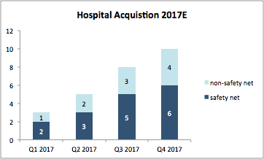

Revenue

Our revenue is generated primarily through fees from hospitals in three forms; 1) license fees 2) integration and 3) maintenance and support. Integration fees are paid in one-time instances, with integrations generally taking one month. Licenses are booked annually and accounted for on a monthly basis (accrual), while maintenance and support fees are collected monthly. As we acquire more customers, we anticipate our revenue mix shifting towards non-safety net hospitals. We associate larger revenue contributions with higher fee structures for non-safety net hospitals as compared to safety net hospitals.

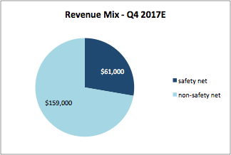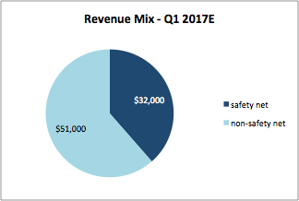

Expenses (Cost of Goods Sold)

Our main cost of goods sold are 1) technical integration, 2) maintenance and support, 3) server and other technical infrastructure costs. We did not include operational expenses (e.g. general and administrative). We anticipate cost of goods to scale proportionally with revenue.

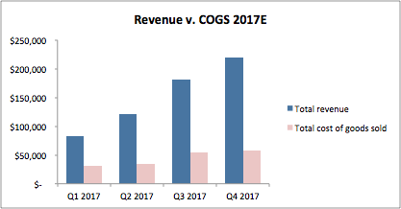

Gross Margin

We anticipate our gross margin to increase overtime as we secure more non-safety net hospitals. Also, in Q4 2017, we expect to launch new application features which present an opportunity to increase top line revenue with minimal impact on costs of goods sold and thus improving our gross margin over time.

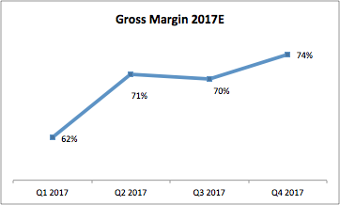

**Engagement Plan**

Initial Outreach and Partnership Development

|  |
| --- |
| **Customer acquisition** |
| **Target customer base**  Hospitals are our target customers. We have a specific focus on safety net hospitals because these organizations are disproportionately affected by patient readmissions and have the most complex and difficult cases of patient care. As a nonprofit, our mission is to enable precision care for the most vulnerable populations. Moreover, safety net hospitals have highly constrained clinical resources. In settings with complex patients and limited resources, our product’s precision recommendations and automated workflows have an outsized impact in optimizing clinical pathways, reducing costs by improving resource allocation, and improving patient outcomes.  **Individuals of interest**  Executive: Chief Information Officer, Chief Medical Information Officer, VP of Clinical Innovation, Chief Financial Officer, Chief Medical Officer  Clinical: Care managers, nurses, physicians, discharge coordinator  **Acquisition strategy**  We have a two-pronged customer acquisition strategy. First, we present a population health management and cost-reduction case to individuals at the executive level. The CIO and CMIO are the lead contacts that determine partnership opportunities, information technology integrations, and establish agreements. Second, we present our product to clinical care teams, who are direct users of our product. We present a case for improved patient management, care coordination, and staff resource reduction. These users become our champions for executives to establish a partnership agreement. |

**Piloting and Implementation**

|  |  |
| --- | --- |
| **Phase 1:**  **Implementation** | **Stakeholders:** information technology staff, chief medical officer, clinical directors  For technical implementation, we engage the information technology teams to integrate our software with their EHR. In this stage, we are mainly building data pipes from the hospitals FHIR API to our system and testing for security compliance. We are also working with the chief medical officer to identify initial roll out to care teams. |

|  |  |
| --- | --- |
| **Phase 2:**  **Training and pilot** | **Stakeholders:** clinical directors, staff physicians, nurses, hospitalists, case managers, discharge coordinator  After technical implementation, we work closely under the guidance of clinical directors to pilot our product with care teams and integrate with existing clinical workflows. This includes role assignment, product training, discharge plan construction, and troubleshooting with care team staff (physicians, case managers, etc.). Importantly, the product is designed with minimal training requirements to improve onboarding. |

|  |  |
| --- | --- |
| **Phase 3**  **Launch and Evaluation:** | **Stakeholders:** information technology staff, C-level, and clinical staff (physicians, nurses, etc.)  After a successful training and pilot phase, we then launch our platform to the hospital, usually including additional technical implementation with information technology staff. We conduct a periodic evaluation to gauge care team satisfaction. We also present executives data to show the impact of our product on population health and care management. These efforts will help drive product iteration as well as further adoption in the hospital. |

**Maintenance and Servicing**

|  |
| --- |
| **Continued Support** |
| **Retraining our model**  The machine learning models that power our software will continue to improve as more hospital-specific data is analyzed with each deployment. We will periodically reconfigure and retrain models to improve performance and robustness.  **Customer support**  In addition to automate security inspections and performance management, we will also provide on-call customer support for hospitals as needs arise. |

**Additional Stakeholders**

* **Patients:** Through our platform, patients receive automated reminders of medical appointments, prescriptions, and other relevant discharge information. This information is relayed to care teams to further continuity of care efforts in their clinical workflows. We hope to expand our patient engagement efforts to address the continuity of care, such as addressing social determinants of health via data sharing.
* **Researchers:** We plan to publish a series of peer-reviewed articles on our predictive models and intelligent clinical workflow recommendations. The adoption and use of our work in the research community could magnify our impact by providing a basis for future innovation.

1. http://www.hcup-us.ahrq.gov/reports/statbriefs/sb196-Readmissions-Trends-High-Volume-Conditions.pdf
2. http://www.aha.org/research/reports/tw/15mar-tw-readmissions.pdf
3. http://www.ahrq.gov/professionals/systems/hospital/red/toolkit/index.html